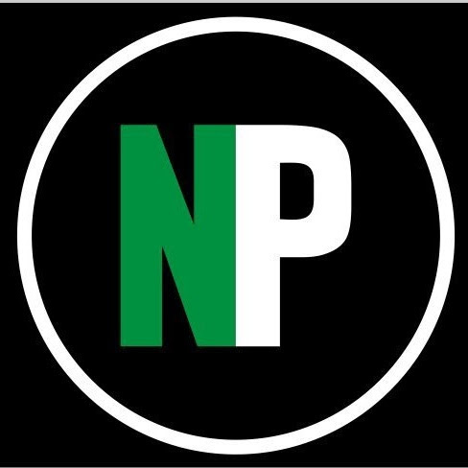
Norwalk High School Percussion
Winter 2020 Assessments

The cost per student for the 2019-2020 Winter Percussion season is $1,000. Below are payment coupons showing the payment due dates and amounts.

Please note that you can reduce or even eliminate your out-of-pocket assessment costs by selling ads for the winter home show program book, selling raffle tickets (will be made available at a later date) or collecting sponsorships.

If you have questions or would like additional information regarding assessment payments, please email Tracey Duff at assessmentsmbi@gmail.com. Be sure to include the student’s name on the subject line.

Any financial hardship or family difficulty should be brought to Mr. Rivera’s attention as soon as possible.
All information will be kept in strict confidence.

Make checks payable to: Marching Bears Inc. (include student’s name on check)
Please include a coupon with each payment so that assessments are credited properly.

Percussion  Payment #5  Due: April 8th  Amount: $200 | Student’s Name: __________________________  Check #: __________  Amount Enclosed: $ __________ | Mail Payment to:  Marching Bears Inc.  c/o Assessments  304 Main Avenue  P.O Box 211  Norwalk CT 06851
Percussion  Payment #4  Due: March 18th  Amount: $200 | Student’s Name: __________________________  Check #: __________  Amount Enclosed: $ __________ | Mail Payment to:  Marching Bears Inc.  c/o Assessments  304 Main Avenue  P.O Box 211  Norwalk CT 06851
Percussion  Payment #3  Due: February 25th  Amount: $200 | Student’s Name: __________________________  Check #: __________  Amount Enclosed: $ __________ | Mail Payment to:  Marching Bears Inc.  c/o Assessments  304 Main Avenue  P.O Box 211  Norwalk CT 06851
Percussion  Payment #2  Due: February 4th  Amount: $200 | Student’s Name: __________________________  Check #: __________  Amount Enclosed: $ __________ | Mail Payment to:  Marching Bears Inc.  c/o Assessments  304 Main Avenue  P.O Box 211  Norwalk CT 06851
Percussion  Payment #1  Due: January 14th  Amount: $200 | Student’s Name: __________________________  Check #: __________  Amount Enclosed: $ __________ | Mail Payment to:  Marching Bears Inc.  c/o Assessments  304 Main Avenue  P.O Box 211  Norwalk CT 06851

